Instrumentation and Monitoring   
*Information Sheet*

*Automated Track Geometry*

**Prepared By**: Lewis Walsh

**Date**: 08/04/2019

**Revision**: 1

**Approved By**: Drew Coulthard

*COMMERCIAL IN CONFIDENCE*

*Do not re-distribute without prior consent.*

*Contents*

Overview 2

Disclaimer 2

Introduction 3

Background 3

Automated track geometry 5

General workflow 6

Prism installation 7

Prism to track offsets 8

Defining the track alignment 9

Interpolation of the track alignment 10

Computation of track geometry parameters 11

Track geometry formulae 13

Overview

This document provides an outline of the workflow and formulae derived by Land Surveys for a conversion between coordinated 3D data points and a representative set of track geometry parameters. These processes and calculations, or variations of them, are the basis for the automated track geometry routine used in Land Surveys third-party software to extract, interpolate and compute between remotely acquired coordinate data and rail specific track geometry parameters.

## Disclaimer

The information contained in these documents is confidential, privileged and only for the information of the intended recipient and may not be used, published or redistributed without the prior written consent of Land Surveys No Problems Just Solutions Pty Ltd.

The information presented is in good faith and while all care has been taken in preparing these documents, Land Surveys No Problems Just Solutions Pty Ltd makes no representations and gives no warranties of whatever nature in respect of these documents, including but not limited to the accuracy or completeness of any information, facts and/or opinions contained therein.

Land Surveys No Problems Just Solutions Pty Ltd, its subsidiaries, the directors, employees and agents cannot be held liable for the use of and reliance of the opinions, estimates, forecasts and findings in these documents.

Introduction

Track geometry parameters are defined as the three-dimensional geometry of track layouts and associated measurements used in the design, construction and maintenance of rail lines. Although, the geometry of tracks is three-dimensional by nature, they are usually expressed in two separate forms for horizontal and vertical components.

Where track geometry degrades with age and usage, or is influenced by nearby construction, it can negatively affect track performance and safety of rolling stock. When track geometry degrades to an unacceptable level, it can lead to derailment, and the consequences can be significant. This may include a high cost of railway operation, economic loss, damage to the railway asset and environment, as well as possible loss of human lives.

Land Surveys automated track geometry system is a means to acquire and report track geometry parameters in near-real time via a contactless method without requiring track possession other than for initial setup and system maintenance. This offers the opportunity for rail operators to retain operability while concurrently attaining high frequency track geometry data.

This system is often used in monitoring projects where the ongoing and uninterrupted measurement of track geometry is required for long periods of time – often initiated by significant construction or excavation activities occurring nearby. The aim of the system is to give the best representation of track geometry values in a manner which closely resembles the values one would attain from manual measurement of track geometry – however – without the need to physically occupy the track or stop the operation of rail services.

Background

In almost all situations, a rail operator requires access to absolute track geometry values which can be directly compared to relevant specifications and allowable geometry limits. Typically, automated track geometry systems offered by monitoring firms may only report in terms of 3D coordinate differences or only report relative track geometry. The distinction between absolute and relative track geometry results is an important concept to understand, as the two options directly impact the interpretation of the data attained by the system and how insightful the data actually is.

Absolute results:

* Represent the true value physical measurement of the track geometry at a given location. These values are a representation of the value you would physically attain from manual measurement techniques.
* For example, this would mean an operator would know a gauge value was initially 1.432m prior to construction works commencing and six months later is measured at 1.437m (has changed by 0.005m) but is still within operating tolerances.

Relative results:

* Represent the change in track geometry between two points in time, these values are not offset or transformed to represent the conditions of a manual measurement. Only the relative change in the estimated parameter is reported.
* For example, the change in gauge starts at 0.000m prior to construction works commencing and six months later we would know that the change in gauge is now 0.005m. Although showing the same change in gauge between absolute and relative results, the trouble is that we don’t know if 0.005m movement is acceptable or not.

In summary, while is advantageous to know that the gauge has changed by 0.005m – with either absolute or relative methods – it is not overly helpful unless if the initial track gauge and its initial relationship to the track design is known. Only then can the difference to design be extracted and tested against a set of limits. Only absolute track geometry will enable this comparison.

The following graphs further illustrate the difference between absolute and relative track geometry – in this instance looking at a cant parameter with a specific 0.015m trigger at a given reporting chainage.

* The chart below shows the difference in cant over a period of time which has been calculated in terms of absolute value. As shown, because the absolute value of the cant parameter was known at the start of monitoring and is referenced to a physical trolley survey, the movement attained since the initial survey indicates that the cant value of this track is now in breach of its allowable limit (the grey dotted line at 0.015m).

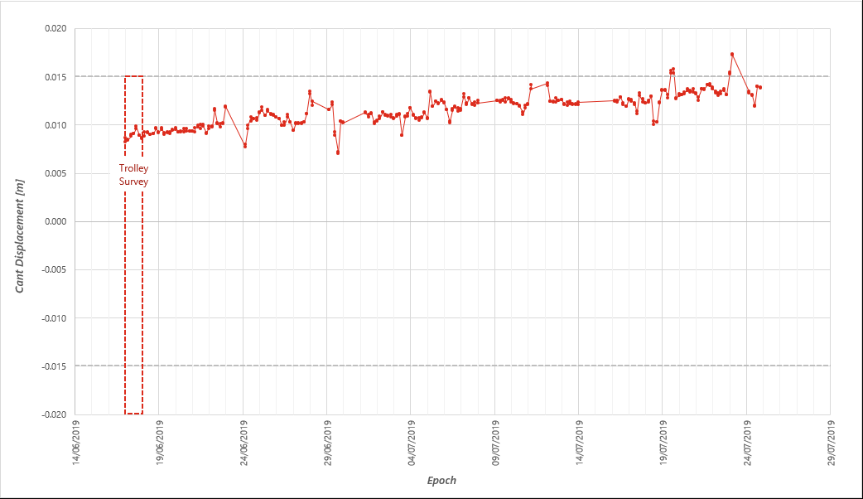

* The chart below shows the exact same data as above but without a relationship to the magnitude of cant at the start of the monitoring period. The same amount of movement attained results in no breach of allowable limit as the commencement point of the relative data started at 0.000m – that is, the initial condition of the track was unknown at the start of monitoring.

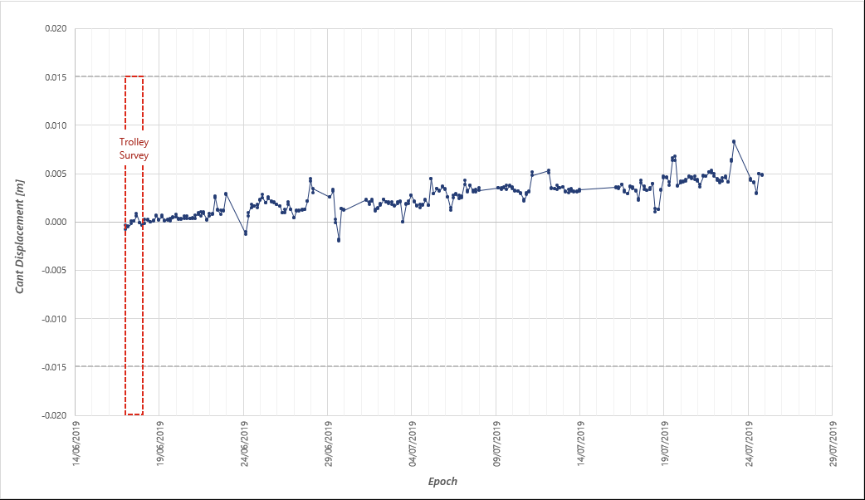

Automated track geometry

The definite and accurate reporting of track geometry is important to Land Surveys, hence we employ techniques and workflows which enable the reporting of absolute track geometry. Steps required for this enablement include:

* Referencing our data to a high accuracy and reliable track survey for initial geometry and alignment data – for example a trolly survey dataset. This gives us a reliable starting point for the condition of the track when monitoring commences.
* Creating and updating prism to rail offsets between our monitoring prisms and the measurement edges of left and right rail heads to ensure calculated geometry is performed between running edges of rail rather than between optical centers of prisms.
* Interpolate the rail alignment used in final computations to ensure continuity of data along the rail line and minimize skewing of the calculated geometry parameters.
* Creating ties between track monitoring prisms and original track design values to ensure the accurate triggering of alarms based on operational geometry limits is possible. This allows us to compare the absolute track geometry value against a design value for any given chainage and report the difference to design and trigger alarms for any resultant breaches.

While the supplementary workflow steps identified above require additional work, without them, there is little assurance that the parameters being reported are correct, or the rail line is safe for operational use.

Surprisingly, the ‘offset’ of prism data to rail heads and the ‘interpolation’ of the rail alignment is typically skipped in some off the shelf automated track geometry programs. This means curve parameters such as radius, line and top cannot be accurately computed but further, cant and/or gauge parameters are often under or over reported as the data used in computations isn’t referenced back to the rail heads.

General workflow

As part of the automated track geometry routine the following steps are autonomously executed at a fixed schedule for each track being monitored.

* Extract the latest 3D prism data from our automated total station control software.
* Sort and group the prism data by chainage and left or right rail.
* Match the known offsets between the reference face of the rail and the prism locations.
* Compute a 'live' rail alignment by applying the offset values to the prism data.
* Interpolate a detailed rail alignment at equally spaced intervals along the track.
* Compute a 'live' set of track geometry parameters.
* Compare the ‘live’ track geometry parameters back to the intended track design.

A network of automated monitoring systems observing X,Y,Z location of optical prisms mounted directly onto the full length of the running rail.

*Prisms are required on both left and right rails with spacing along the track to allow adequate calculation quality for resultant geometry parameters (particularly on curved sections prism spacing is important).*

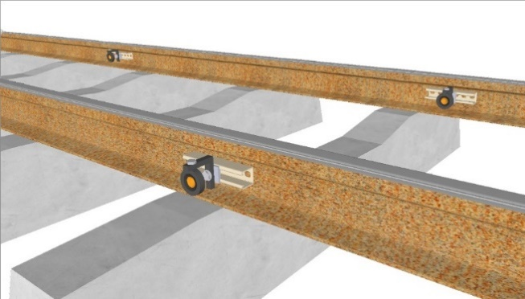

*1. Observe*

Each new set of prism data captured is offset onto the running edge of the track in ‘near-real time’.

*With reference to an accurately captured rail alignment (i.e. via trolley survey). The 1D offset, 2D offset and chainage relationship between each rail prism and the running edge of the track can be generated and applied.*

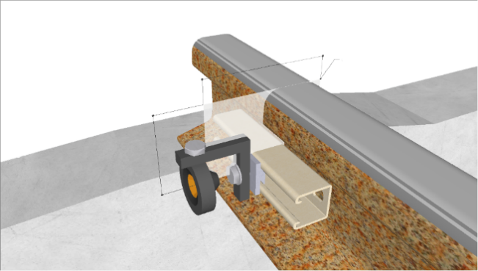

*2. Offset*

*2D Offset*

*1D Offset*

*Chainage*

The ‘live’ offset prism data is then used to determine the ‘live’ alignment of the track with interpolated track nodes at equal chainage intervals.

*Interpolation will be based on the latest set of available prism data to ensure that the attained alignment is a true representation of the ‘live’ track condition.*

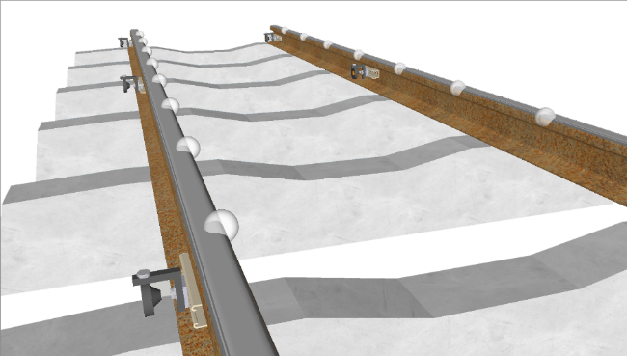

*3. Interpolate*

Based on the ‘live’ alignment at each calculation epoch, a ‘live’ set of geometry parameters can be determined.

*Attainable parameters, at any given reference length, include:* ***Cant (superelevation), twist, line (horizontal versine), top (vertical versine), gauge, radius and alignment.***

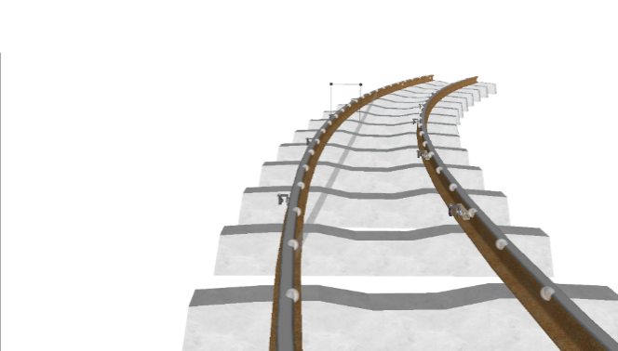

*4. Compute*

*Line*

Prism installation

To calculate track geometry parameters on a set or rail lines, we require installation of optical prisms to aid in gathering movement data relevant to the track.

* For this, the prism must be installed directly to the track or on track elements which will allow the prisms to deform in an identical manner to the rail while also being safe from obstruction or clashes with running trains. For this reason, the preferred installation location is on the web or foot of the rail, as shown below.

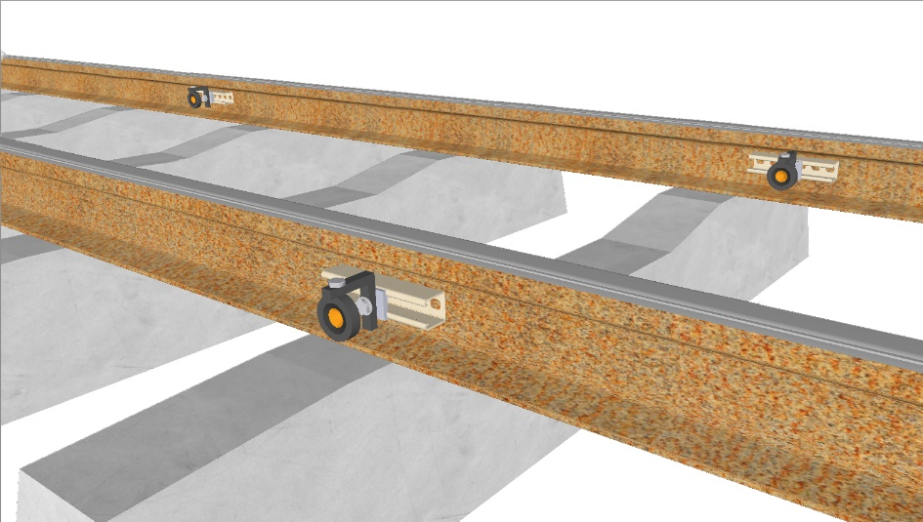

Several mounting options are available for direct prism installation onto components of the running rail. Examples of some available mounting options include:

|  |  |  |  |
| --- | --- | --- | --- |
| Method | Description | Benefits | Disadvantages |
| FRP Unistrut | Fibre-reinforced Unistrut mounted to rail web with adhesive. Web is buffed and primed prior to mounting. Uni-strut fixings used to connect an optical prism to the Unistrut. | * Fiber-reinforced strut creates a non-conductive and non-corrosive barrier between prism and rail. * Prism can be detached from strut if required. | * One time use mounting. * Strut is mounted for long term occupation. Once glued in place it is expected to remain in place until the end of monitoring. |
| Rail Clamp | Custom-made stainless-steel clamp which attaches to the foot of the rail. Clamp has threaded bolt holes form mounting of an optical prism. | * Reusable clamping system with interchangeable prism options. * Nondestructive mounting system. | * Metallic product creates electrical bond with rail. * Expensive unit cost due to custom fabrication requirements. |
| Survey Plug | Expanding survey wall plug drilled and installed into concrete or wood sleepers. Optical prism mountable via plug. | * Cost effective and quick mounting option for short term possessions. | * Requires drilling into sleepers. * Prism and rail may move independently with each other due to mounting location. |

Prism to track offsets

Traditionally, manual measurements of track geometry parameters involve observations to reference points on the head or running edge of the rail and taping or leveling between these physical surfaces. With geospatial based automated systems, it is not possible or practical to observe directly to the rail head while maintaining repeatability and accuracy. Alternatively, automated systems produce a set of discrete XYZ coordinate data with respect to the optical centre of each prism mounted to a component of the rail. The means the raw observed XYZ data attained is not suitable for direct geometry calculations in its raw form.

Beware of venders offering geometry values in this manner without additional processing steps… the reported parameter values will not represent the true absolute geometry of the track.

To ensure the reported geometry parameters from the automated system closely represent the result you would attain from a manual measurement technique, each observed prism must be offset onto the measurable surface of the track.

*2D Offset*

*1D Offset*

*Chainage*

For this to be possible the following information is needed:

* The exact location of the rail head needs to be known – that is, an as-built survey of the track in its current form is required. This is typically derived from a track trolley survey or similar.
* The monitoring prisms need to have been installed on the rail and have been observed during the trolley survey or have been observed at a very similar epoch. This ensures a true correlation between prism and track data. *There is little point in calculating offsets between prism locations acquired today to a trolley survey performed 5 years ago – the global locations of the prisms and/or track are likely not comparable.*

Piecing together all the offset prism data for the left and right rails from a live set of monitoring data generates a series of track nodes which represent the live alignment of a monitored track. In addition to this, each prism is assigned a chainage so that there is a correlation between the projected track node and chainage of the rail line.

Defining the track alignment

As a result of linking together the track nodes derived from the offset prism data, we can now generate a live XYZ alignment for a given track for the given epoch of monitoring data as illustrated below.

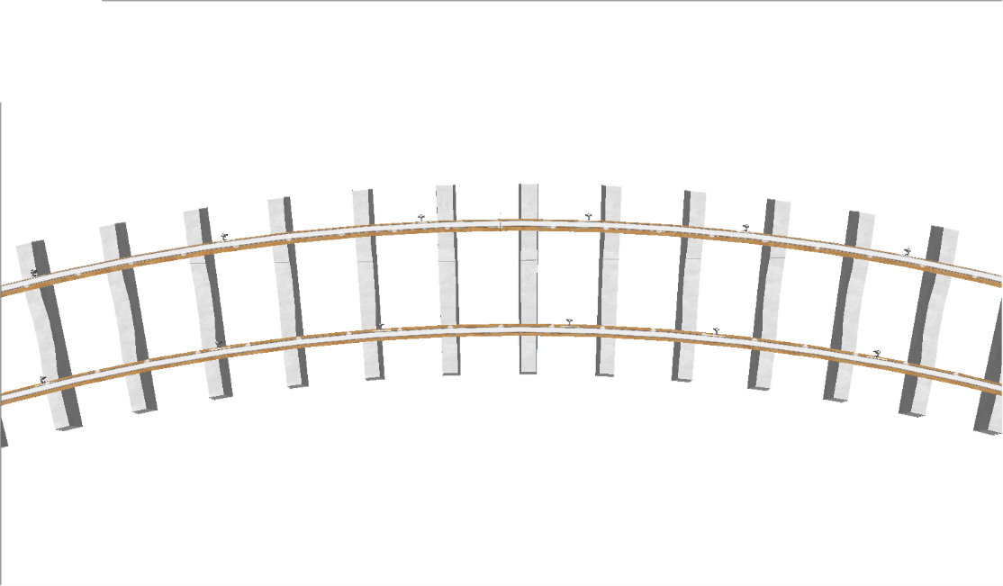

*XYZ Alignment*

One key component to note from this live track alignment is that the track nodes which have been derived from the prism data, represent the XYZ location of the rail at the chainage of each observed prism. Due to the difficulty of installing prisms at exact millimeter chainages, this means the XYZ track alignment data will contain unequal and unaligned coordinate data across the left and right rail heads. The illustration below visually shows this misalignment.

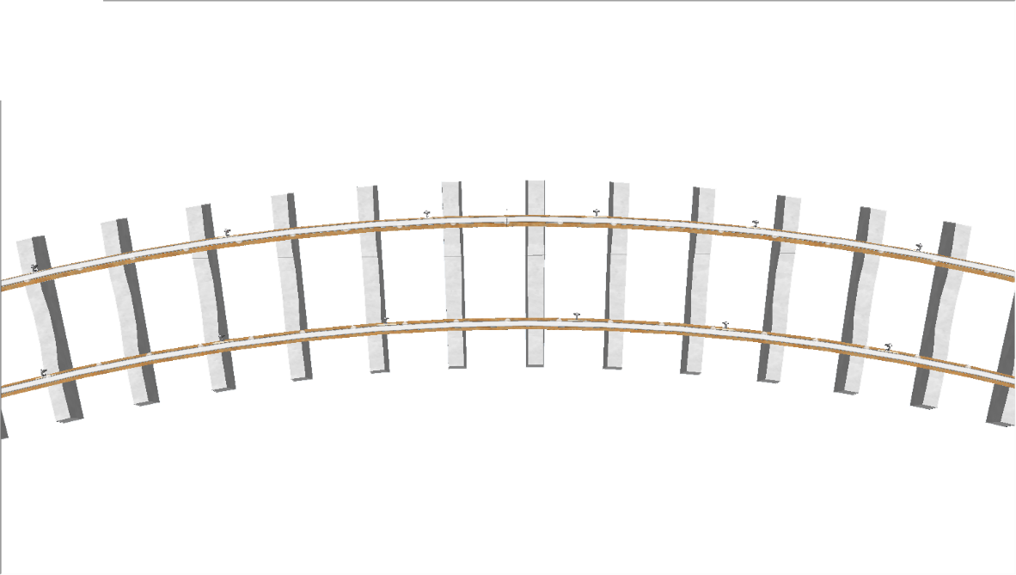

*CH 022.3*

*CH 024.5*

*CH 026.1*

*CH 028.9*

*CH 022.0*

*CH 024.1*

*CH 025.9*

*CH 028.6*

If the outcome of this process was to report a XYZ alignment only, this would not be an issue, but as we are attempting to re-create the conditions you would expect if manually measuring track geometry, it is not suitable to use the track nodes in their current form. For example:

* If required to report track gauge or cant, the data in its current form would be unsuitable as the track nodes are not perpendicular with each other across the left and right rail heads.
* If required to report top, line or twists, the data in its current form would be unsuitable as the separation of the track nodes along the length of each rail head are unlikely to be at the lengths required for calculating mid ordinate versine’s or twist lengths. For example, you may require an 8.0 meter chord for a top parameter but the track nodes available are at a spacing of 12.6 meters.

Interpolation of the track alignment

To overcome the issue previously discussed – where the prism generated track nodes are misaligned across the left and right rails and unequally spaced along the length of the rail heads – the available track nodes for a given epoch of monitoring data go through one final set of processing.

This final step involves the standardisation of the track nodes so that they become uniformly spaced along the length of the rail and at intervals which are compatible with the calculation required lengths for a given set of track geometry parameters. Within this final step, the prism-based track nodes are treated as a discrete set of known data points and from these, a given number of new data points are generated via interpolation of the original track nodes. An example of these newly interpolated track nodes is illustrated below:

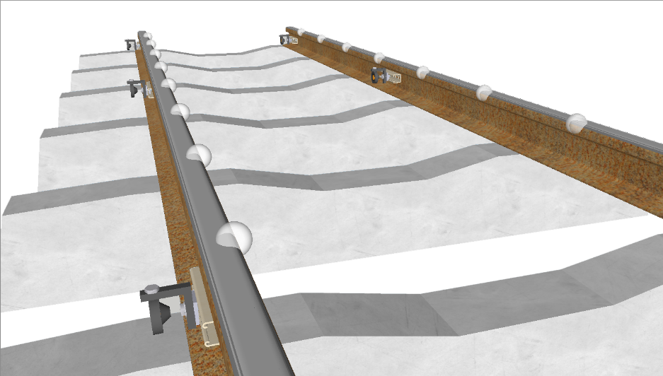

*CH 023.0*

*CH 023.5*

*CH 024.0*

*CH 024.5*

*CH 025.0*

*CH 025.5*

*CH 026.0*

*CH 025.5*

*CH 025.0*

*CH 024.5*

To ensure that the validity of the prism-based measurements is not smoothed or overcompensated for during this interpolation stage – which would result in the true geometry of the track being over or under reported. Every single prism-based track node is treated as a fixed location which the newly interpolated track alignment must pass through. This ensures that the interpolated track nodes represent the most likely form of the track rather than the most simplified or approximated form of the track.

Computation of track geometry parameters

With all data handling and pre-processing steps now complete, the final task is the computation of the required track geometry parameters. A list of the typical parameters generated by Land Surveys automated track geometry software is given below:

* Track Gauge: the internal spacing between the rails on a railway track. This is measured perpendicularly between the inner faces of the load-bearing rails.

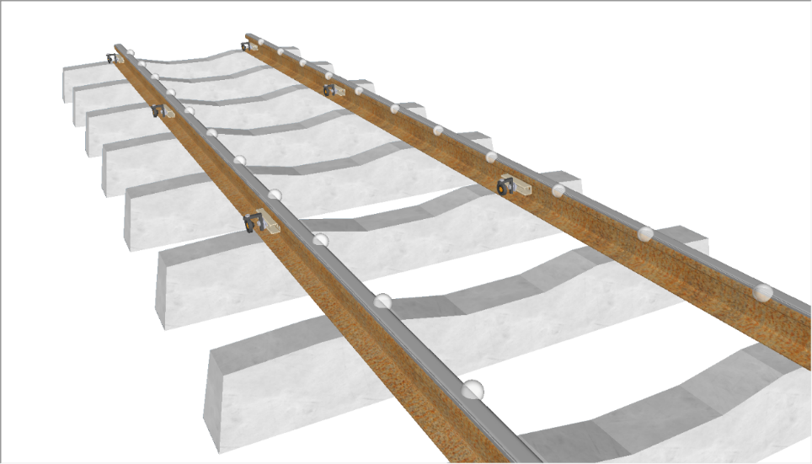

*Gauge*

* Track Cant: also referred to as superelevation or camber, is the cross slope or the rate of change in elevation between the two left and right rails, measured perpendicularly from one rail head across to the next.

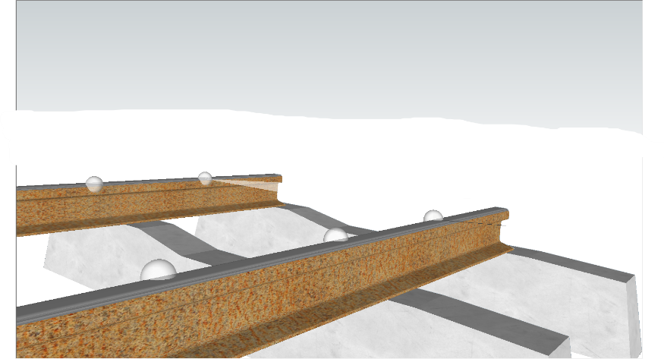

*Cant*

* Track Twist: the difference in the track cant between one point of measurement and the next along the length of the track. The distance between the first and second track cant values is fixed during the measurement and is called the base of the twist. This parameter is also often described as the rate of change in track cant.

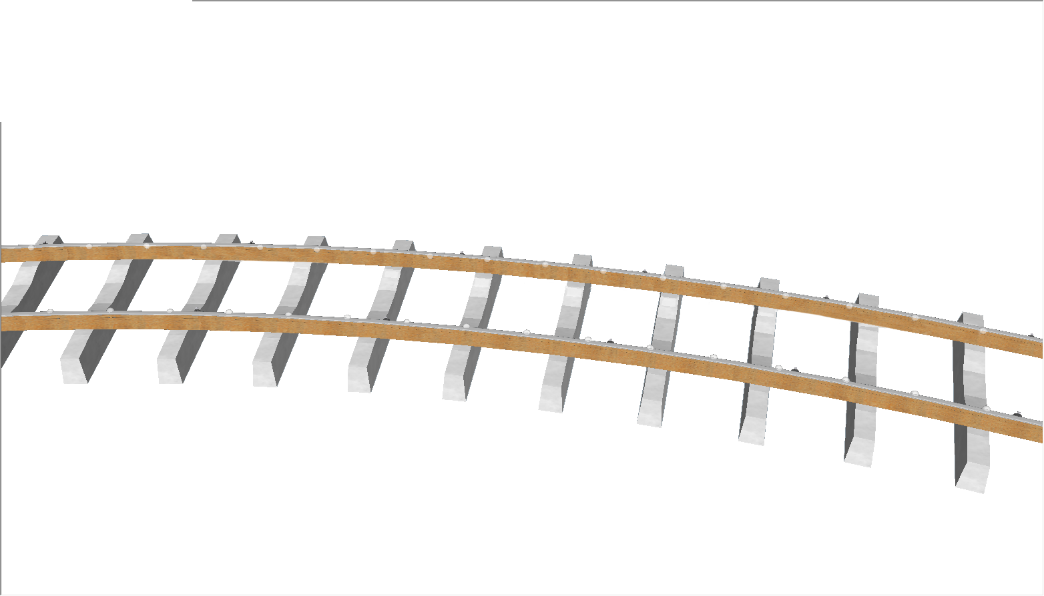

*Twist*

* Track Line: also referred to as a horizontal versine, is a parameter used to assess track curvature in the horizontal plane. The measurement of this parameter is derived from a chord of fixed length being stretched from one point on a rail head to another point a fixed length ahead of the first. The top parameter is then defined as the length of the perpendicular offset at the middle of the chord which extends to the running edge of the rail head.

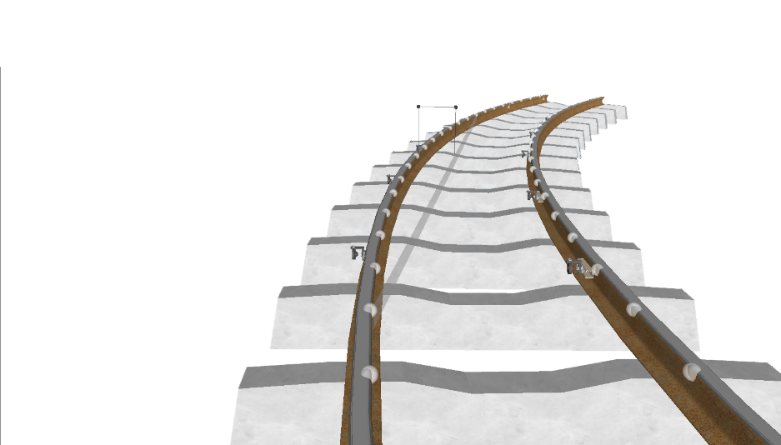

*Line*

* Track Top: also referred to as a vertical versine, is a parameter used to assess track curvature in the vertical plane. This is the same mathematical calculation as track line but with the vertical component only. The measurement of this parameter is derived from a chord of fixed length being stretched from one point on a rail head to another point a fixed length ahead of the first. The top parameter is then defined as the length of the perpendicular offset at the middle of the chord which extends to the running edge of the rail head.

Track geometry formulae

The following formulae represent the computations performed in near-real time for every new set of monitoring data that is acquired through the automated track geometry system. Please note the following:

* Where an $X, Y or Z$ variable is listed in the following formulae, this refers to the 3D coordinate position of an interpolated track node at a given chainage $ch$- not the 3D coordinate position of a prism.
* Left rail and right rail data is represented by the $LR and RR$ subscript.

Track Gauge

$$Gauge_{ch}=\sqrt{{\left(X_{{ch}_{LR}}-X_{{ch}_{RR}}\right)}^{2}+{\left(Y_{{ch}_{LR}}-Y_{{ch}_{RR}}\right)}^{2}+{\left(Z_{{ch}_{LR}}-Z_{{ch}_{RR}}\right)}^{2}}$$

Track Cant

$$Cant_{ch}=Z_{{ch}_{LR}}-Z_{{ch}_{RR}}$$

Track Twist

$$Twist_{ch}=Cant_{ch}-Cant_{ch-l}$$

$$where l=given twist base length$$

Track Line

*Please note, track line is calculated for both left and right rail separately. In this instance, each of the $X,Y and Z$ variables in the equations below will be substituted with left rail or right rail data only – not a mix of both. The chainage at which the line parameter is reported will be the chainage at the middle of the chord.*

$${Line}_{ch}=\frac{{{HC}_{ch}}^{2}}{8∙{HR}_{ch}}⋅\frac{{Δθ}_{ch}}{\left|{Δθ}_{ch}\right|}$$

$$with$$

$${HR}_{ch}=\frac{{HC}_{ch}⋅{HB}_{ch}⋅{HC}_{ch}}{\left({HA}_{ch}+{HB}_{ch}+{HC}_{ch}\right)\left({HA}_{ch}+{HB}_{ch}-{HC}_{ch}\right)\left({HC}_{ch}+{HA}_{ch}-{HB}_{ch}\right)\left({HB}_{ch}+{HC}_{ch}-{HA}_{ch}\right)}$$

$${HC}_{ch}=\sqrt{{\left(X_{ch}-X_{ch-l}\right)}^{2}+{\left(Y_{ch}-Y_{ch-l}\right)}^{2}}$$

$${HB}_{ch}=\sqrt{{\left(X_{ch+l}-X_{ch}\right)}^{2}+{\left(Y_{ch+l}-Y_{ch}\right)}^{2}}$$

$${HC}_{ch}=\sqrt{{\left(X_{ch+l}-X_{ch-l}\right)}^{2}+{\left(Y_{ch+l}-Y_{ch-l}\right)}^{2}}$$

$$where l=half of the required chord length$$

$${Δθ}_{ch}=θ_{full}-θ_{mid}$$

$$θ_{full}=\tan^{-1}\left(\frac{X_{ch+l}-X_{ch-l}}{Y_{ch+l}-Y_{ch-l}}\right)$$

$$θ_{mid}=\tan^{-1}\left(\frac{X_{ch}-X_{ch-l}}{Y_{ch}-Y_{ch-l}}\right)$$

$$where l=half of the required chord length$$

Track Top

*Please note, track top is calculated for both left and right rail separately. In this instance, each of the $X,Y and Z$ variables in the equations below will be substituted with left rail or right rail data only – not a mix of both. The chainage at which the top parameter is reported will be the chainage at the middle of the chord.*

$${Top}_{ch}=\frac{{{VC}_{ch}}^{2}}{8∙{VR}_{ch}}⋅\frac{{Δα}_{ch}}{\left|{Δα}_{ch}\right|}$$ $$with$$ $${VR}_{ch}=\frac{{VA}_{ch}⋅{VB}_{ch}⋅{VC}_{ch}}{\left({VA}_{ch}+{VB}_{ch}+{VC}_{ch}\right)\left({VA}_{ch}+{VB}_{ch}-{VC}_{ch}\right)\left({VC}_{ch}+{VA}_{ch}-{VB}_{ch}\right)\left({VB}_{ch}+{VC}_{ch}-{VA}_{ch}\right)}$$ $${VA}_{ch}=\sqrt{{\left(Z_{ch}-Z_{ch-l}\right)}^{2}+{\left(l\right)}^{2}}$$ $${VB}_{ch}=\sqrt{{\left(Z_{ch+l}-Z_{ch}\right)}^{2}+{\left(l\right)}^{2}}$$ $${VC}_{ch}=\sqrt{{\left(Z_{ch+l}-Z_{ch-l}\right)}^{2}+{\left(2l\right)}^{2}}$$ $$where l=half of the required chord length$$ $${Δα}_{ch}=α_{full}-α_{mid}$$ $$α_{full}=\tan^{-1}\left(\frac{2l}{Z_{ch+l}-Z_{ch-l}}\right)$$ $$α_{mid}=\tan^{-1}\left(\frac{l}{Z_{ch}-Z_{ch-l}}\right)$$ $$where l=half of the required chord length$$